JOBSHEET I

BASIC PROGRAMMING

* 1. **Learning Objective**

After finishing this practicum, students will be able to:

1. Understand of conditional statements, loops, array, and function
2. Implementation of using conditional statements, loops, array, and function in code program
   1. **Conditional Statements**

The theory of this practicum is already explained in Basic Programming course. Therefore, in this practicum session we will do a quick review of your understanding by answering the following questions.

* + 1. **Practicum of Conditional Statements**

**Questions**

1. Create a program to calculate final score of students with these compositions. 20% of final score comes from assignment score, 35% from midterm score, and 45% from final exam. Each input score ranges from 0 – 100. Once the final score is determined, do the conversion as follows:

|  |  |
| --- | --- |
| **Score** | **Alphabets** |
| 80 < N ≤100 | **A** |
| 73 < N ≤80 | **B+** |
| 65 < N ≤73 | **B** |
| 60 < N ≤65 | **C+** |
| 50 < N ≤ 60 | **C** |
| 39 < N ≤ 50 | **D** |
| N ≤ 39 | **E** |

If the acquired alphabets are A, B+, B, C+, C then the student is **passed.** Otherwise, the student is **failed.**

* The program needs inputs for assignment score, midterm, final exam score
* The output will be the final score, its alphabet, and information whether they **passed** or **failed**

**Example:**

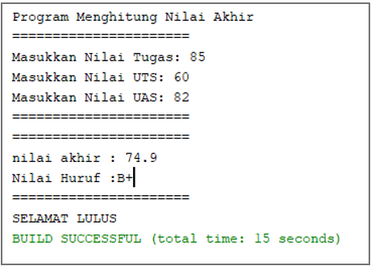

* 1. **Loops**

The theory of this practicum is already explained in Basic Programming course. Therefore, in this practicum session we will do a quick review of your understanding by answering the following questions.

* + 1. **Practicum of Loops**

**Question**

1. Create a program that can display the day from Monday to Sunday repetitively with days amount is n, the n will be the last 2 digits from your NIM.

*if n < 10, then add 10 (n+=10)

Example:

Input NIM: 2041720010, then n = 10

***OUTPUT: Monday Tuesday Wednesday Thursday Friday Saturday Sunday Monday Tuesday Wednesday***

2nd Example:

Input NIM: 2041720002, then n = 12

***OUTPUT: Monday Tuesday Wednesday Thursday Friday Saturday Sunday Monday Tuesday Wednesday Thursday Friday***

**Example result:**

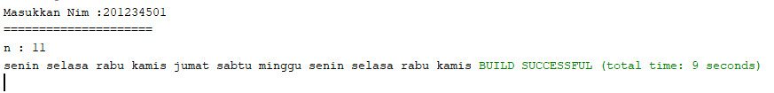

* 1. **Array**

The theory of this practicum is already explained in Basic Programming course. Therefore, in this practicum session we will do a quick review of your understanding by answering the following questions.

* + 1. **Practicum of Array**

**Question**

1. RoyalGarden is a flower shop that has many branches. Every day, the sold flowers and its stock has recorded as follows

|  |  |  |  |  |
| --- | --- | --- | --- | --- |
|  | Aglaonema | Taro | Alocasia | Rose |
| RoyalGarden 1 | 10 | 5 | 15 | 7 |
| RoyalGarden 2 | 6 | 11 | 9 | 12 |
| RoyalGarden 3 | 2 | 10 | 10 | 5 |
| RoyalGarden 4 | 5 | 7 | 12 | 9 |

The price for each Aglaonema is 75.000, Taro is 50.000, Alocasia is 60.000, and Rose is 10.000. Please help RoyalGarden to create a program that can calculate:

1. Stock for each flower through all branches
2. If there is an additional information about a stock has decreased since the flowers are wither or dead on RoyalGarden 1 branch. Those dead flowers are 1 Aglaonema, 2 Taros, and 5 Roses. Please calculate the income of RoyalGarden 1 if all flowers are sold out.
   1. **Function**

The theory of this practicum is already explained in Basic Programming course. Therefore, in this practicum session we will do a quick review of your understanding by answering the following questions.

* + 1. **Practicum of Function**

**Question**

1. Create 2 functions for:
2. Display Fibonacci row using loop
3. Display Fibonacci row using recursive function

Notes:

Fibonacci row: 0, 1, 1, 2, 3, 5, 8, 13, 21

* + 1. **Assignment**

1. Smile Laundry is a laundry service that costs its customer as follows:

* Cost for each 1kg clothes is Rp 4.500
* If the customer does laundry more than 10kg clothes, they will get 5% discount

Today, the laundry has 4 customers, those are Ani, Budi, Bina, and Cita. Ani brought 4kg clothes, Budi brought 15kg clothes, Bina brought 6kg, and Cita brought 11kg. Create a program to calculate the income of Smile Laundry at that day.

1. Somebody saves 1 million rupiahs in a bank. With its interest is 2% for each month, then in what month does the customer balance reach 1.5 million? Create a program for this case study.
2. Create a program that can display even numbers from 2 until nth row, unless the even number is a multiple of 4.

Example:

Input of n: 5

output: 2, 6, 10, 14, 18

1. Create a program that includes a function to:
2. Menu (to choose a calculation for area of triangle / rectangle / circle)
3. Calculate area of triangle
4. Calculate area of rectangle
5. Calculate area of circle